Programming Assignment #3. Develop application with list, stack or a queue ADT with Exception handling and Data implemented as Generic Type.

Main objective is to illustrate implementation of generics in OOA. To do it data stored in ADT instead of concrete ItemType has to be declared as generic <T>. Later (in main class), in order to actually use it you have to cast to a specific ItemType you have.

Project includes Application to use ADT, ADT itself, YourItemType class, YourExceptions, interfaces and required blocks to handle exceptions in a main application class.
Remember the naming requirement. Each class should have some personal information in the name.

Class diagram (use generics <T>) could be similar to what you had in the Project #2:

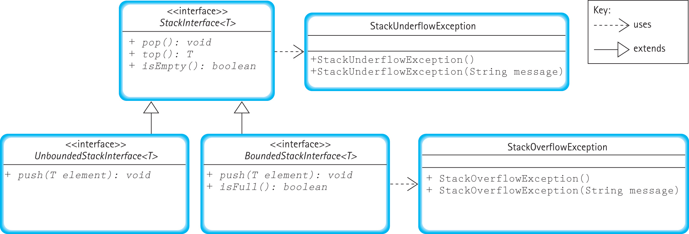

All other specifications are identical to what you had in a Project 2.

New mandatory components:
- Main function has try/catch blocks
- Use of interfaces
- Use of exceptions
- Use generic data type

Optional features:
- use input data file and output file for testing
- provide full unit test functionality at least for one function
- use bounded version of ADT.

Possible enhancement could be use of a Test Driver that would read test data from the data file, and then runs unit test for all methods implemented in ADT.

Deliverables: .java, .class, data and readme files (from 11 to 15 in total)
Readme file has to include relative to your project UML class diagram.

